Exploration of caves in northwestern Guangxi Province, SW China: 11th Britain-China Expedition, October 2000

Arthur Clarke
School of Zoology, University of Tasmania (AUSTRALIA)
(Email: akclarke@utas.edu.au)

Introduction

Based on the PowerPoint presentation at the 23rd ASF Biennial Conference in Bathurst, this following report mainly relates to speleo expedition experiences in China and their outcomes, particularly in regard to cave fauna. There are also some observations of the magnificent karst landscape that is so prevalent in this part of southern or SW China and brief mention of some cultural aspects. In addition to some geology, geomorphology and history, the report also includes some background material relating to organisation of speleological expeditions, a chronological history of listing the past expeditions undertaken by overseas speleo groups, plus information relating to previous studies and collections of cave fauna in China.

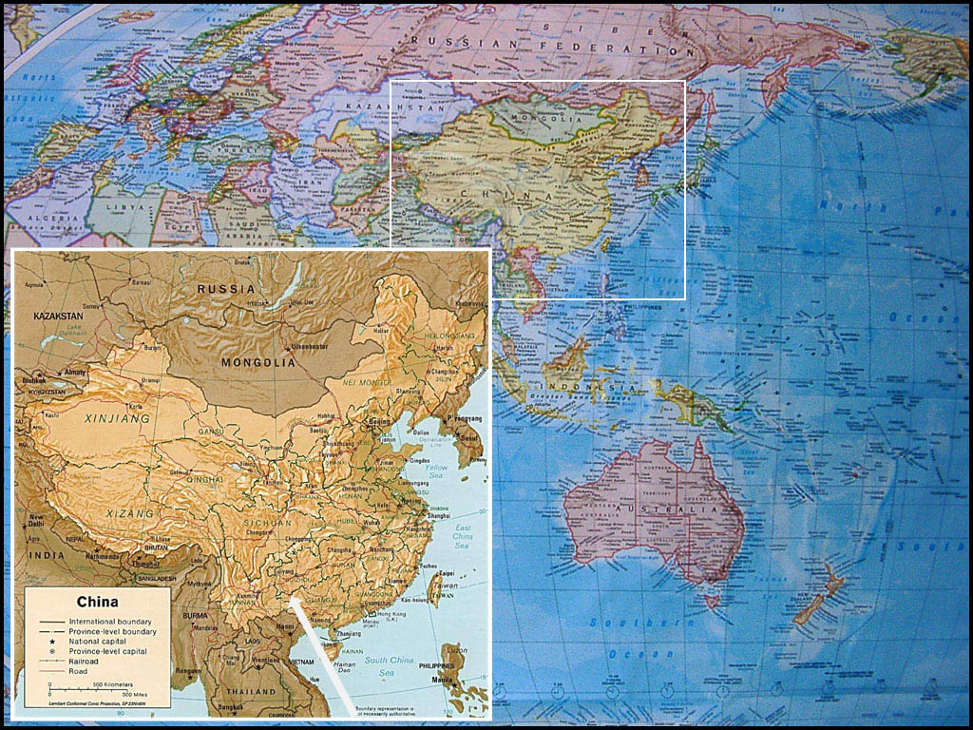
Figure 1: Map of Australasia, the western Pacific and Europe, showing location of China in relation to Australia and New Zealand. Inset map of China with arrow point to expedition area of NW Guangxi. Based on maps in Clarke & Latella (2001) and Clarke (2002). [Map sources: Australian Geographic wall map & Internet map.]

Some background (how did I get to be there?) and arrival in China
It is sometimes said that caving, or international caving, is all about networking! In mid-1999, two English cavers (Ged Campion and Bruce Bensley) were here in Tasmania as part of a brief holiday trip to Australia. Both were members of Yorkshire Ramblers Club (YRC) and
the Wolverhampton Caving Club. The day after attending a meeting of Southern Tasmanian Caverneers (STC) in Hobart, Jeff Butt and I took Ged and Bruce out to the Junee-Florentine karst to do one of our classics: a Slaughterhouse Pot/ Growling Swallet through trip. During the course of our STC trip, we spent a brief bit of time in the Trapdoor Streamway near Avens Aven and Scaling Pole Aven, where Ged and Bruce saw a few of our cave adapted invertebrate species as they were being observed and collected by Arthur Clarke. I maintained contact with both of them and later that year - during a visit to England in December 1999 - I was formally invited to join their forthcoming expedition to SW China. Apart from the fact that they also wanted to have a biologist on their expedition, they were generally keen to enhance the scientific component of the expedition by having some academic speleologists assist in the exploration of caves in northwestern Guangxi Province.

The recent Guangxi 2000 expedition (Figure 2), led by Ged Campion, was planned by members of two British caving clubs: Wolverhampton Caving Group and Yorkshire Ramblers Club (YRC). 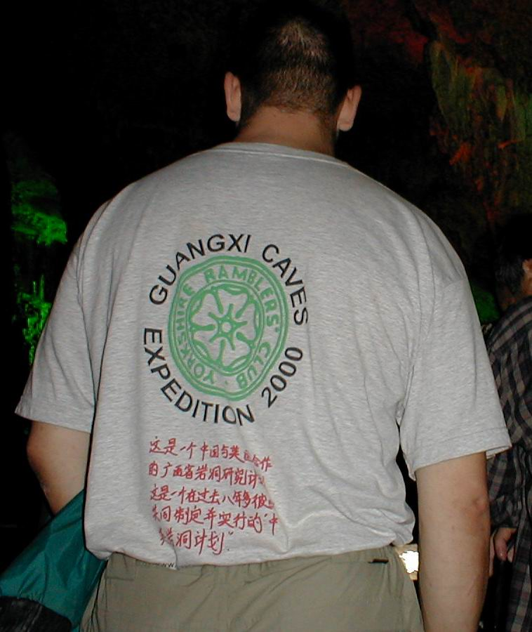

Figure 2: "Guangxi Caves 2000 Expedition" T-Shirt designed exclusively for our exploration team.

There were 16 expeditioners in the Guangxi 2000 team: 13 from England, one from Ireland, one from France and myself from Australia. We entered China via Shanghai, and then flew south to Guilin, where we were met at the airport by our hosts from the Institute of Karst Geology (IKG) and a film crew from Nanning: the capital city of Guangxi Province. We were immediately ferried off into the thriving and busy city of Guilin: a beautiful city bustling with commercial activity and new building developments, set in a backdrop of magnificent tower karst. For some of us it was a real culture shock: seeing so many people together in one spot with streets crammed with cyclists, pedestrians and all manner of vehicles going in all directions at once, but no traffic lights! Fortunately, the traffic flow was quite slow, but it took a bit of dutch courage crossing a Guilin street on foot for the first time. Apart from being in awe with our new and crowded surroundings, we were introduced to our hosts including Prof. Zhu Xuewen and staff associates from the IKG (generally better known as the “Karst Institute”), plus Andy Eavis: a long time China campaigner and leader of many China Caves Project expeditions to southern China. 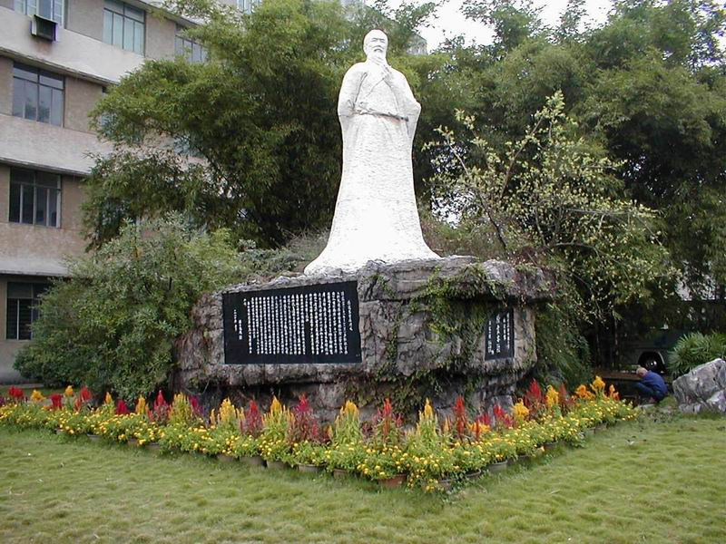

Figure 3: Statue of Xu Xiake (1587-1641) outside the Institute of Karst Geology in Guilin. Considered as the “father” of karst studies in southern China, he recorded details of over 350 caves in the 4-year period from 1636-1640.

After familiarising ourselves with the Karst Institute and viewing the statue of Xu Xiake – a karst geographer from the Ming Dynasty -, we inspected the IKG China Caves Project gear store (Figure 4) and examined its contents.

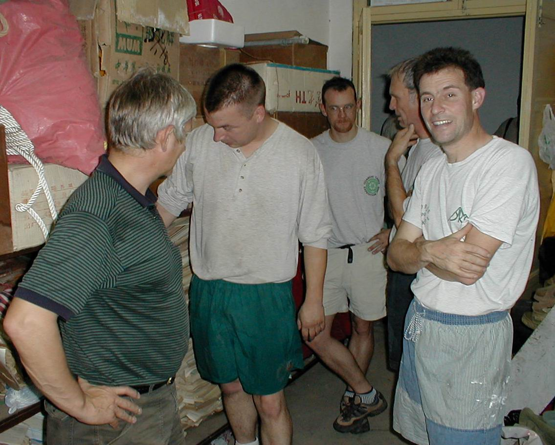

Figure 4: Andy Eavis (on left) with Ged Campion (RHS) and other expeditioners inspecting contents of the China Caves Project gearstore at the Karst Institute, prior to departure to Lingyun County.

Getting amongst the karst of SW China

The following day, our introduction to the karst of China took on a new meaning, as we were taken on a Chinese tourist ferry for a boat ride down the Li Jiang (Li River) introducing us to the picturesque riverside karst of southern China (Figures 5, 6, 8 & 9). On this ferry trip – where our 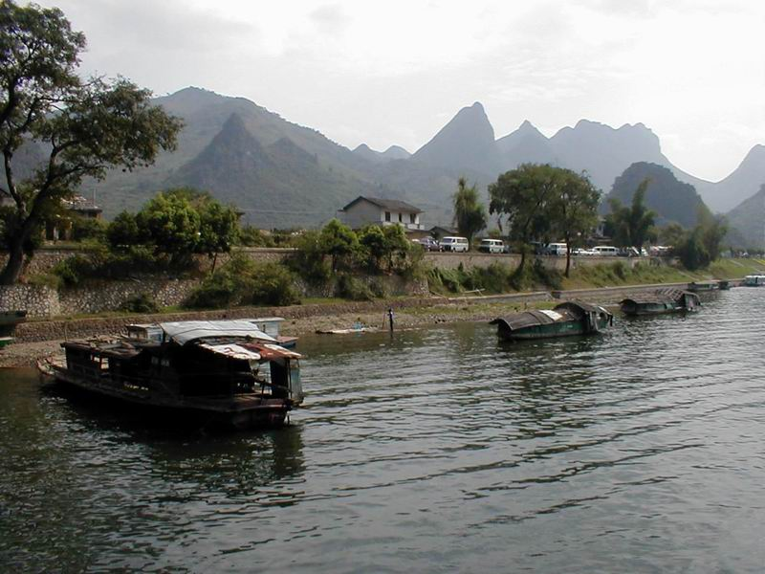

Figure 5: Sampans and houseboats on the Li Jiang near the entrance to Crown Cave with cone karst behind. Originally known as Guan Yan Dong, this cave was explored and suryeyed by members of the first team of UK cavers (led by Andy Eavis) who came to China in 1985.

ferry was one of about 150 other ferries doing the daily return trip from Guilin to Yangshuo – we were introduced to snake wine and chopsticks to eat our first banquet meal, then shown maps of the planned three week “Guangxi 2000” expedition area (Fig. 13). We were going to be based at Lingyun in Ling-yűn Hsien or Xian (Lingyun County) in northwest Guangxi Province. This remote Lingyun County region is apparently better known as a source of green tea, than for its karst. Tea plantations (Figure 25) are grown on the slate rock soils of steep hillsides that lie between the outcrops of limestone. 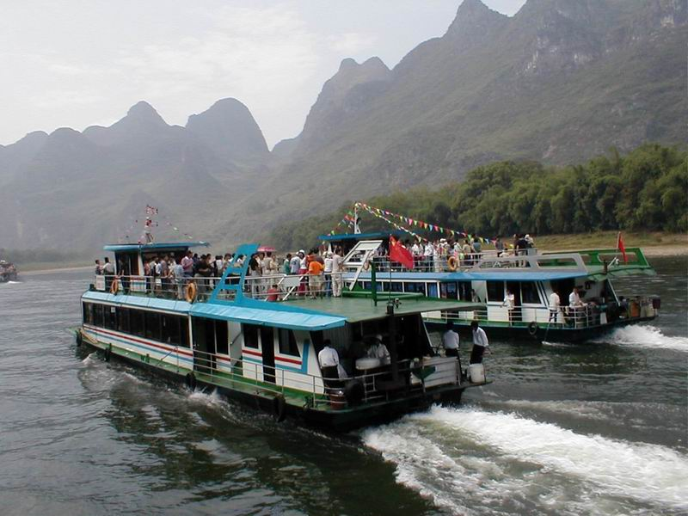

Figure 6: Passing ferries head down the Li Jiang river from Mopanshan (Mopan Hill) Wharf, 28km south of Guilin for the 55km river journey to Yangshuo.

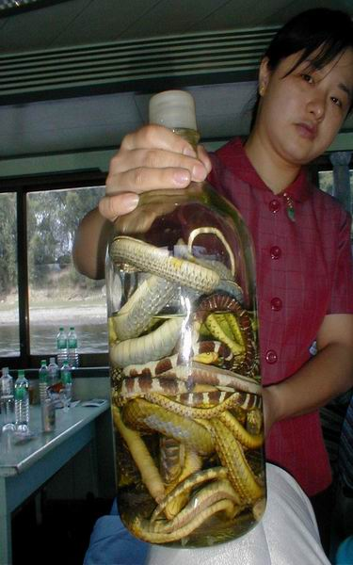

Figure 7: Snake wine (with pickled snakes) on offer to expeditioners during the Li Jiang ferry ride to Yangshuo.
Guangxi is a quite large province: around 241,000 km2 (10% larger than the state of Victoria, Australia) and is divided into eight regions (ti-ch’ű) with 72 counties (hsien or xian), eight autonomous counties (tzu-chih-hsien) and six major municipalities (shih) or cities (Geelan and Twichett, 1974).

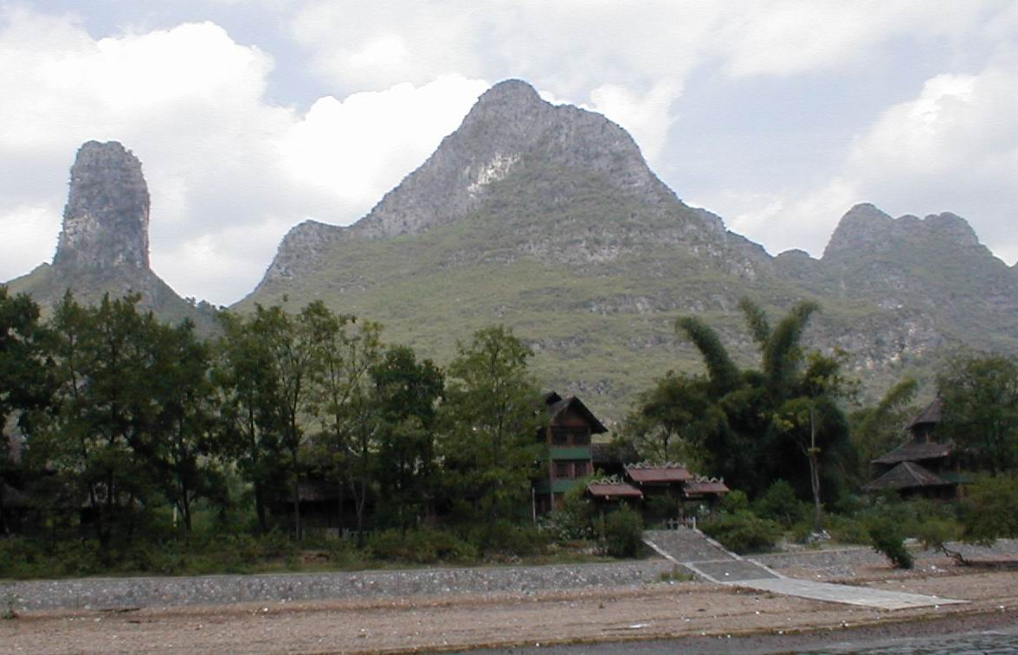

Figure 8: Karst beside the Li Jiang river: obelisk-like tower karst (LHS) and cone karst hills in centre and on RHS.

Most of the karst in the outlying counties of provinces, such as Guangxi, appears to be largely unexplored. However, the karst is very extensive, so the only areas that are generally investigated are those obvious sites close to the major arterial roads that connect the more populated rural centres and villages. Our “Guangxi 2000” expedition was the l1th Britain-China cave exploration team and we were about to engage in the first known extensive exploration of a relatively remote area of cone karst in the counties of Lingyun and Leye - in the far northwest of Guangxi Province - where it borders with Guizhou in the north and Yunnan in the west. This bordering area of Yunnan and Guizhou forms part of a unique inclined karst plateau, abbreviated as the “Yungui” plateau, with the gradual incline (Figure 17) rising as you go north. As shown in Figures 1 and 10, our exploration area was also relatively close to the North Vietnam border.



Figure 9: Together on the ferry to Yangshuo with cone karst backdrop, Prof. Zhu Xuewen (from the Institute of Karst Geology in Guilin) with Ms. Cheiry Lixin who (with husband Chen Lixin) was producing a television documentary of our “Guangxi 2000” expedition.

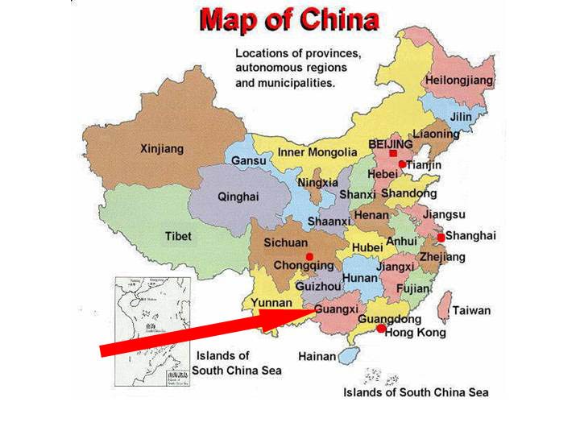

Figure 10: Map of China showing provinces with arrow pointing to the Lingyun area (near the “G” of “Guangxi”) in the far northwest of Guangxi Province, where our expedition was based”. [Map sourced from Clarke & Latella (2001).]

